Part 1 – Calculating the Circumference of a Circle
In this part of the assignment, I created a function named print_circum() that takes one argument, the radius of a circle, and prints the circumference using the mathematical formula Circumference = 2πr. Instead of manually typing π, I used the math module, which provides the value of pi with high precision. This makes the calculation accurate and shows how Python modules can be used to perform mathematical operations. Then I called the function three times using different radius values (parameters).
Explanation of Output
When the function is called, Python substitutes the radius value into the formula 2 * math.pi * radius. The math.pi property retrieves π from the math module, and the multiplication produces the circumference. The result is printed through an f-string to ensure a readable and formatted output.
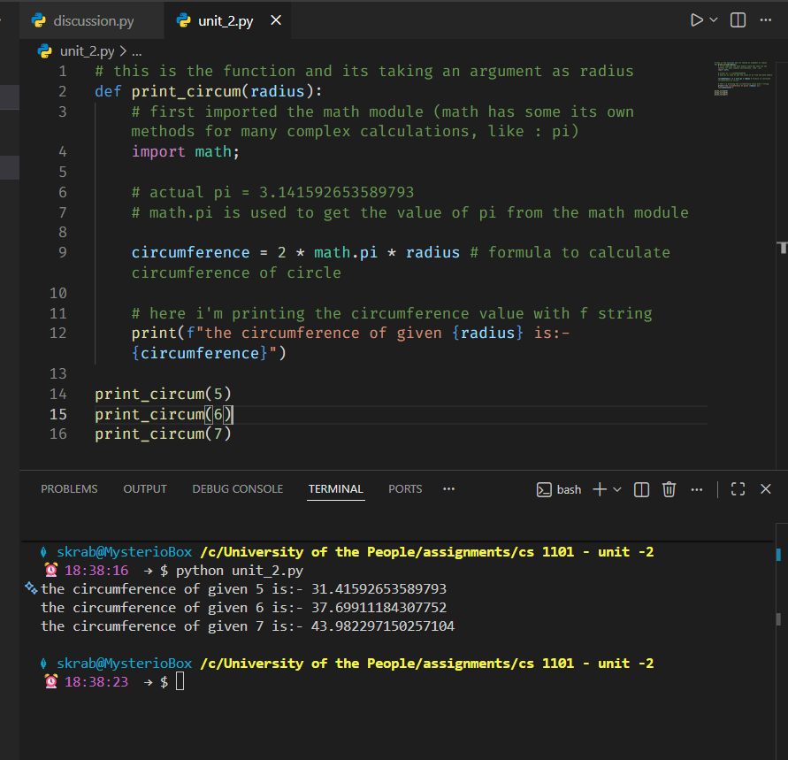

Part 2 – Online Store Catalog Function
For this project, I designed a function called online_store_catalog() that prints an online store’s price list. The company sells three items individually, offers three different two-item combo packs at a 10% discount, and a full gift pack of all three items at a 25% discount. Inside the main function, I created a nested function named total_with_discount() which calculates the total price for any selection of items and applies the correct discount depending on how many items are included.
This solution demonstrates several Python concepts:
- Dictionaries for storing item prices
- Functions and nested helper functions
- Arguments and parameters
- Conditional logic using if, elif, and else
- Formatted output using f-strings for clean alignment
- Mathematical expressions for computing discounts
Explanation of Output
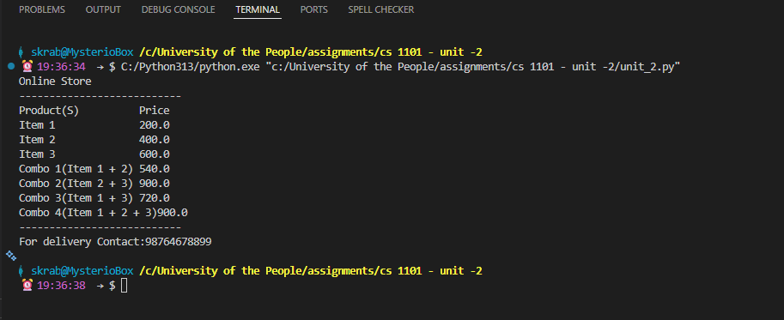
The function prints a product catalog similar to a printed receipt. It first shows prices for individual items without discounts. Then it prints combo prices with discounts automatically applied through the helper function. The string formatting (<20) ensures that all product names align neatly in the left column while prices appear in the right column.

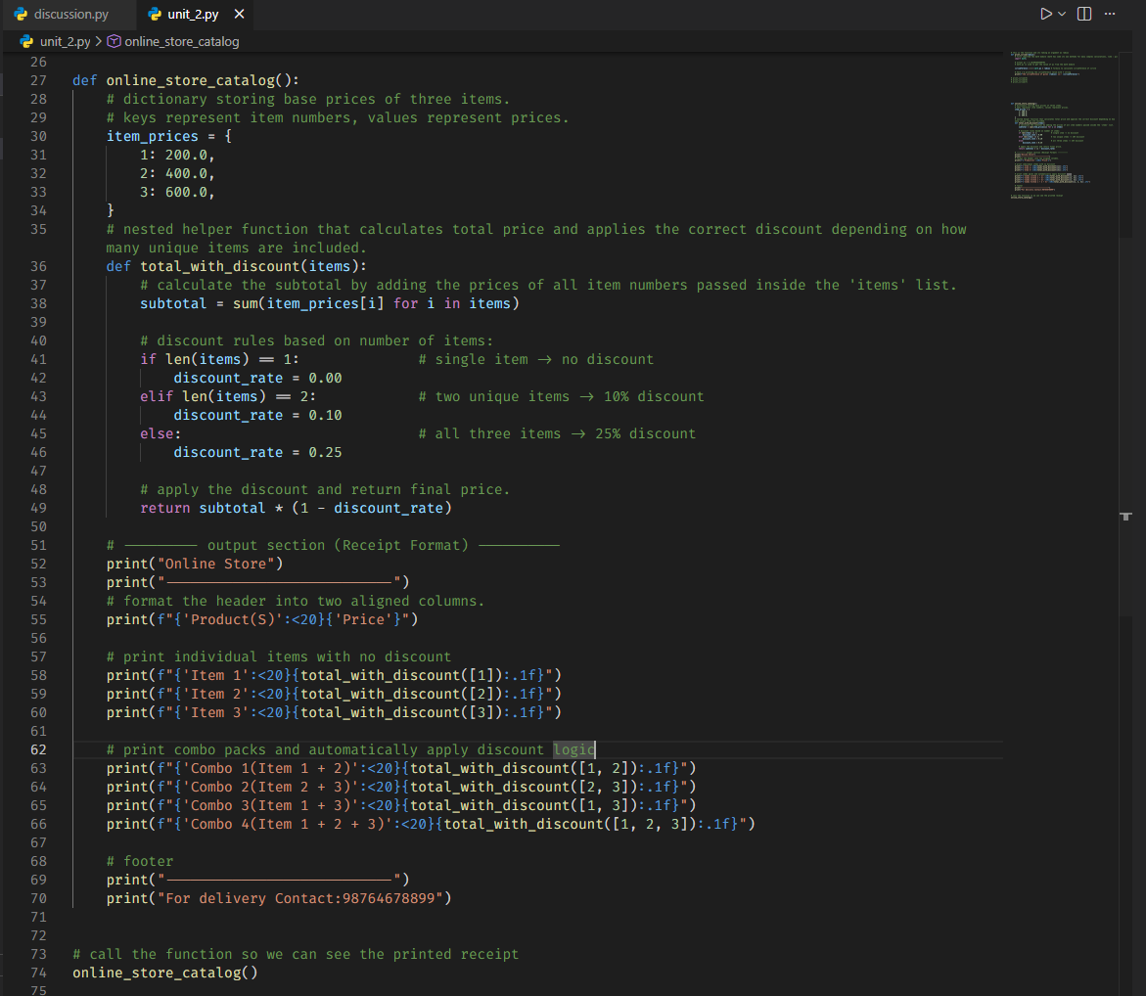

Conclusion
This assignment helped me reinforce the concepts of variables, expressions, and function definitions in Python. Part 1 demonstrated how parameters, imported modules, and mathematical operations work together to compute a real-world formula. Part 2 extended this knowledge by using dictionaries, conditional logic, nested functions, and formatted printing to build a functional mini-project. These programming fundamentals form the foundation for writing more complex programs, and the exercises reflect the topics described in Chapters 2 and 3 of Think Python by Allen Downey.

References
Downey, A. (2015). Think Python: How to think like a computer scientist. Green Tea Press. https://greenteapress.com/thinkpython2/thinkpython2.pdf

